Ethereum (ETH): Price Analysis and Predictions for the Future

The crypto space is heating up in recent times. Taking the last few months into consideration, most of the high market cap coins are now in the green, on the back of increased trading activity and a huge price uptrend which has led to a bull run going strong for several months now.

In this article, we’ll examine one of the top, most-valuable cryptocurrencies in the market by a mile, Ethereum.

Overview
Ethereum is the world’s second-largest cryptocurrency by market capitalization; truly, it’s cemented its place behind Bitcoin for a while now. Launched back in 2015, Ethereum was always a departure from the ‘cryptocurrency’ narrative common to platforms launching around that time like Litecoin, Ripple XRP, NEM, etc.
Instead of being used as a cryptocurrency just like every other platform in the space, the co-founders (particularly Vitalik Buterin and Joseph Lubin) wanted so much more for Ethereum. They wanted to truly harness the power of blockchain technology and decentralized computing.
So, instead of just one layer of transactional and computational capability, the Ethereum network envisioned three layers. Of course, the first layer was the cryptocurrency side of things. It was a distributed ledger that relied on a network of nodes to process and verify transactions with the native cryptocurrency ether (ETH).
The second layer, the smart contracts layer, uses its native language called Solidity to help create automatic, self-executing contracts. This was a revolutionary feature as it would allow anyone to benefit from the decentralized, trustless nature of blockchain technology.
The third and final layer houses the Ethereum Virtual Machine (EVM), famously dubbed "the Ethereum World Computer". The EVM was designed to facilitate the development and deployment of decentralized applications (dApps) on top of the Ethereum network.
The idea was that a blockchain network should be able to harness the collective processing power of a network of nodes (computers) around the world. This would ultimately create a form of a decentralized global supercomputer which is available to everyone.
While Ethereum has shown great promise as a platform for building and deploying dApps, it’s been plagued with transaction scalability issues over the years, a scourge which has prevented the network from reaching its full potential. It has also caused some uncertainty regarding ether (ETH) and its price index. Despite an impressive display during the 2017 bull run, things seemed to have slowed down.
However, ETH has gained momentum over the past couple of years through two key events. First was the explosion of the decentralized finance (DeFi) sector, which the Ethereum network has largely dominated. A defining moment for Ethereum this year is the announcement of the new Ethereum 2.0 network upgrade, which has had a positive effect on the price of ETH.

Fundamental Analysis
In short, Ethereum promised a lot during its early days of inception and exploded into the scene after the CryptoKitties game. It became more popular during the 2017 bull run when it became the most-traded cryptocurrency after Bitcoin.
Besides being used as a platform for exchanging value, it has numerous practical use cases broadly categorized as: providing much-needed computing resources and a self-sustaining network.
Through smart contract functionality, the Ethereum blockchain allows people to improve business workflow by digitizing assets and creating self-executing lines of code which automatically handle the value transfer process in a contract without the need for a third party.
It even serves as a launchpad for other platforms to launch their cryptocurrency, resulting in a cascade of new cryptocurrencies that have rocked the crypto space. Most of the coins launched in 2017 and onwards are based on the Ethereum blockchain.
However, the network proved to be a little out-of-date and inefficient as time went by. The Ethereum developers, therefore, went to work and outlined a complete network overhaul called Eth2.
According to the Eth2 FAQ by blockchain development company ConsenSys, “Phase 0 is the first step toward changing the consensus mechanism of Ethereum from proof-of-work to a proof-of-stake. With proof-of-stake, validators commit a stake and run software to secure the Ethereum 2.0 chain. Phase 0 of Ethereum 2.0 will launch the beacon chain, which will establish and maintain the proof-of-stake consensus mechanism…”
Simply put, the primary focus of the new system is to move away from the slow, energy-intensive Proof-of-Work (PoW) mining algorithm and move to a more focused, agile Proof-of-Stake (PoS) consensus protocol. The new system will be deployed slowly over the next two years.
During the Great Bull Run of 2017, Ethereum rose to an astounding $1,432. However, shortly after, the price index collapsed badly due to its limitations and surrounding market factors, reaching as low as $80 at one point.
Now, with the planned Ethereum 2.0 deployment around the corner, the price index has seen a healthy uptick. Still, the recovery hasn’t been as impressive as Bitcoin’s which has nearly re-attained its all-time high.
The truth is, Bitcoin delivered what it promised to be; a decentralized currency system — just that. Ethereum, on the other hand, is still working out its kinks and needs to step up. For now, its fate is determined by the success of Eth2, and it will shoot up in value as we’ve never seen.

Technical Analysis
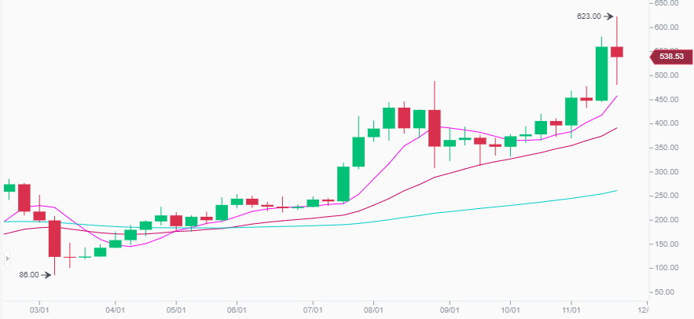
Looking at the weekly ETH graph, there is a distinct trend towards the upside. The 7-day and 25-day Weighted Moving Average (WMA), indicated by the pink and red lines, clearly show that there is still a strong bullish trend. The 99-day WMA (blue line) is very flat in comparison, but it nonetheless forms a gradual upwards slope over this period. The charts show that the bulls are very much active, and ETH is yet to run out of steam.
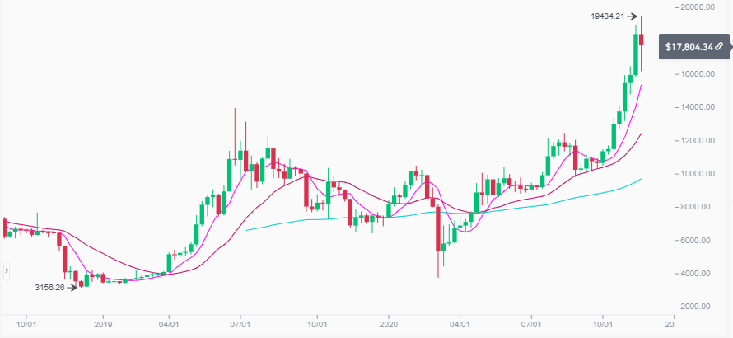
When you compare the ETH price index with BTC's, you will notice that there is still a strong correlation between the two. Though a bit smoother, the 7-day WMA, 25-day and 99-day WMA are nearly identical.
This correlation might not last much longer though, with ETH 2.0 around the corner. Surely, there will be a massive interest in the second largest coin and a successful move towards PoS from PoW. This would make the Ethereum network faster, efficient and more secure, further driving up the demand and value of ETH.
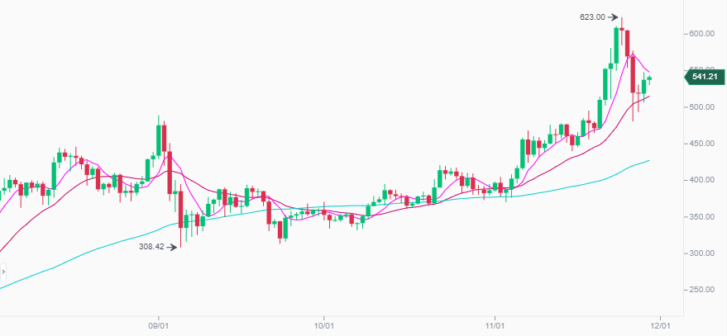
The trend remains the same if we zoom into daily view from the above weekly ones. With two major dips that still follow the BTC trend, where the crashes were attributed to BTC Futures expiring and traders deciding to liquidate their long positions, especially when BTC was challenging its all-time high a few days ago.
However, even with Eth2 launched, the massive uptick in ETH's price might see a major correction and fall back, probably even below its current value. ETH's non-correlation with BTC will be short-lived, and it will eventually establish itself again once the hype around the upgrade settles down.
Furthermore, here's a chart showing ETH's price over six months:
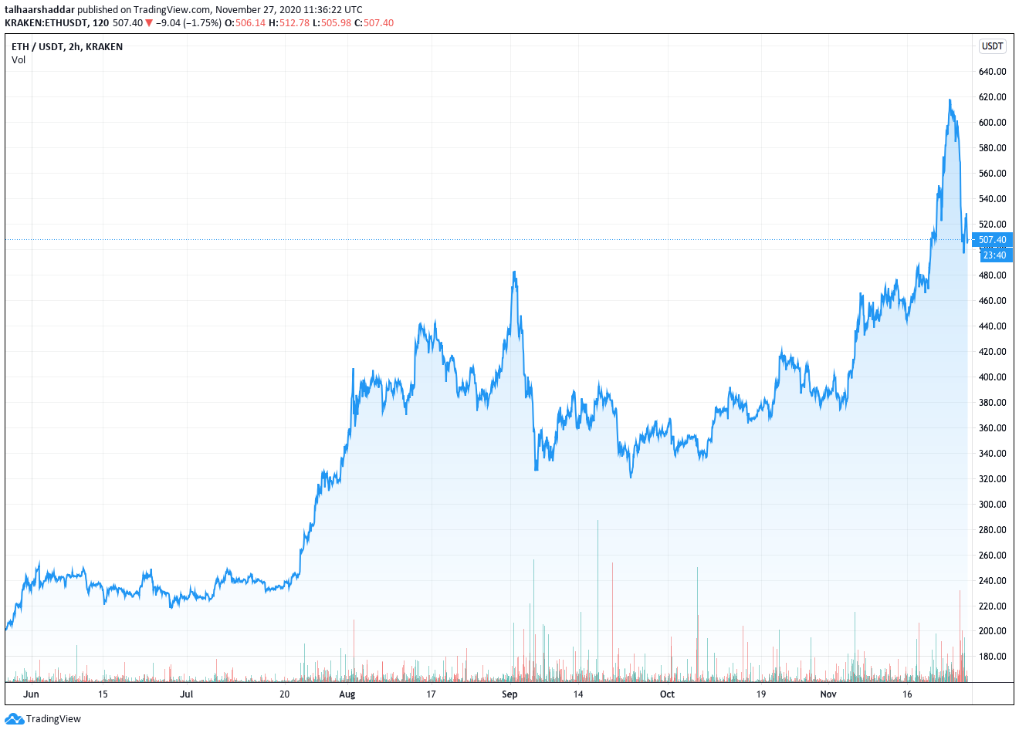
As you can see, the general trend is towards the upside. However, it is also a well-known fact that Bitcoin sets the trend in the cryptocurrency market. Here is the graph of Bitcoin during the same period under review (i.e., the last six months):
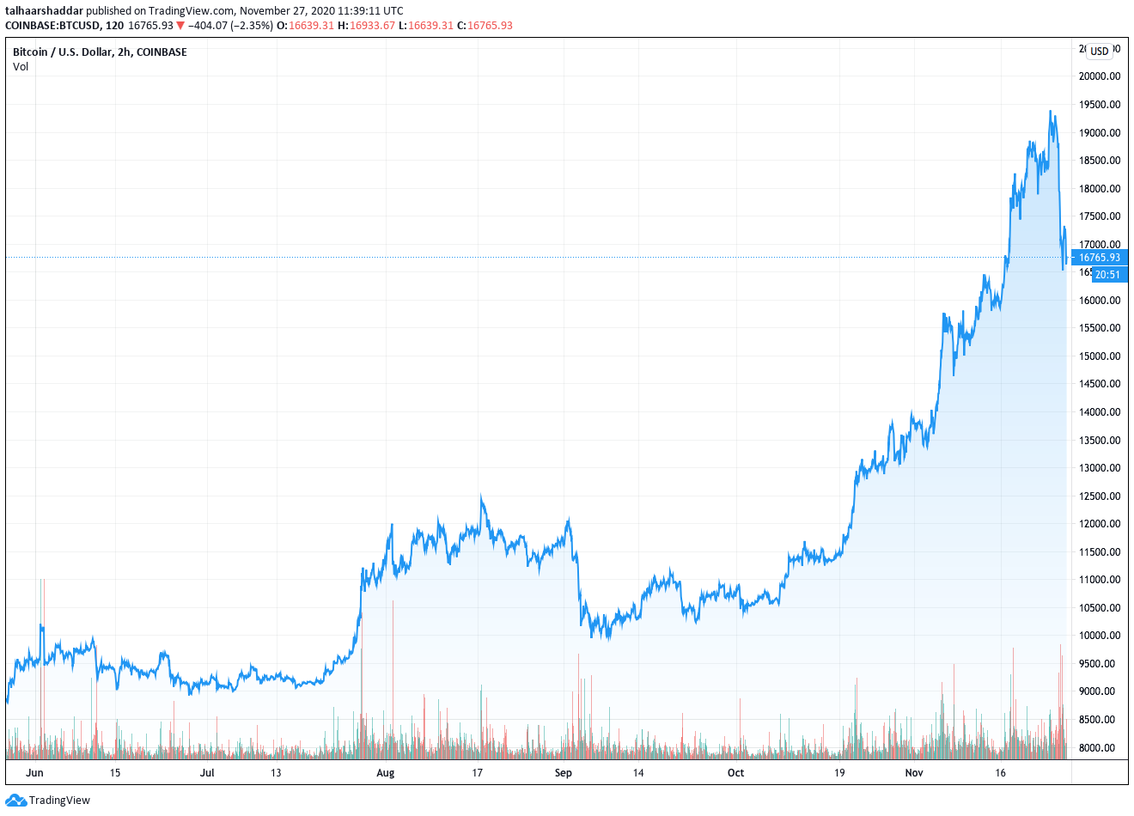
There’s a pattern forming here: Bitcoin rallies, Ethereum rallies also.
No doubt, Bitcoin has also posted a much better performance during these last six months. It’s quite clear that Ethereum has mimicked Bitcoin’s price movement over this period. Here is a chart showing Ethereum’s performance over the last 30 days:
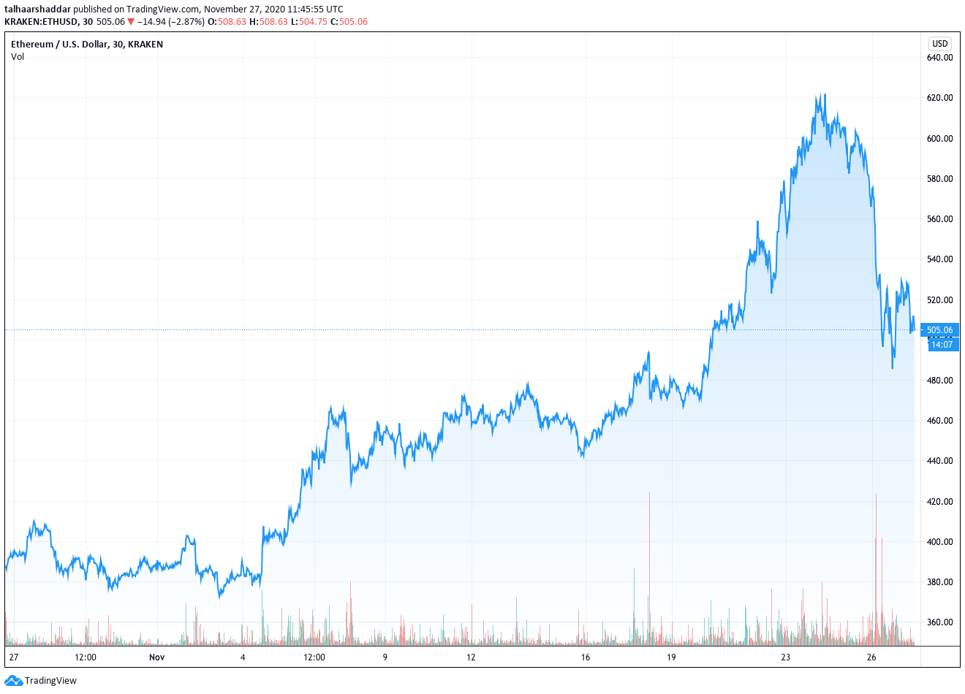
As you can see, the anticipation around Ethereum 2.0 is building and the cryptocurrency is gradually gaining momentum. If the trendline continues, a significant price increase by early next year is a strong possibility.
It’s noteworthy that despite the latest correction, ETH is up by more than 27.3% in a 30-day window and gained 248.0% over the past year. Even more, the cryptocurrency is still showing increased interest among buyers and has consistently defended its key support levels. This indicates strong bullish signs which could prove helpful in overturning the brief dip and
The first phase (branded “0”) of the Ethereum 2.0 upgrade is going to be launched at the start of the next month. Eth2’s success will result in another price rally if everything goes according to plan.

Future Projections
Based on the technical and fundamental analysis, ETH’s prediction regarding the next few months is that the price will continue to show bullish behaviour. While much is dependent on Bitcoin’s price index as it sets the tone for the rest of the pack. Based on the projections, the price index can rise as high as $1,000 during the next few months and possibly higher.
In the long term, Ethereum’s price index will depend on the success of the planned Ethereum 2.0’s upgrade and also on Bitcoin’s price index (due to its dominance in the cryptocurrency market). Over the coming year, a few minor updates and announcements will be made and the cryptocurrency could rise to as much as $2,000.
For the next five years, the Ethereum network will be very different from what it is right now. Thanks to the Eth2 upgrade, ETH can rise to as much $5,000 if everything goes according to plan.

Conclusion
Ethereum is a unique cryptocurrency. Apart from Bitcoin, the rest of the cryptocurrencies piggyback on its success and try to stay relevant. However, Ethereum is the only other cryptocurrency that can paint itself a bright future with its real-world use cases.
All in all, its success for the foreseeable future depends on whether it can achieve the needed scalability and sustainability being promised in the planned Ethereum 2.0 upgrade.

